SIMATS ENGINEERING

CSA10 – SOFTWARE ENGINEERING
ASSIGNMENT 1
Design, Simulate and Validate an Agile Delivery Strategy for the Omnichannel Order Fulfilment Platform

STUDENT DETAILS
Name | K. Sreelatha
Register Number | 192425248
Programme | B.Tech – CSE (AI & ML)
Course | CSA10 – Software Engineering
Assignment Nature | Individual
Total Marks | 50

Declaration and Evidence Note
This report presents an Agile delivery strategy for the omnichannel order fulfilment platform described in the assignment brief. Stakeholder findings, sprint events, delivery indicators and Jira-style board visuals in this report are simulated for academic planning because no actual stakeholder interview or Jira execution evidence was supplied. They must not be represented as real project activity. The screenshots are illustrative artefacts prepared to demonstrate the proposed backlog, workflow, release plan and redesign.
The assignment brief specifies synthetic products, orders and stock movements, and prohibits the use of real customer or card data. Payment gateway access may be unavailable; therefore, this strategy keeps local order/payment records and designs safe retries without claiming live payment processing.

Executive Summary
The retailer needs a connected order journey across its website, mobile application and twelve stores. The main problems are failed orders, slow refunds and unclear ownership of orders. This report proposes a four-sprint, eight-week release using a tailored Scrum and Lean approach managed in Jira. The first release focuses on a complete basic journey: order creation, stock reservation, warehouse picking, dispatch status, support lookup and an auditable refund-approval path. Advanced analytics and full automation are deferred so that the team does not spread its capacity across nine incomplete modules.
A seven-member cross-functional team is assumed for the baseline plan. The first sprint is simulated and used to identify dependency and clarification delays. A revised plan is then developed for two regional warehouses, a second team, regional rules and the loss of the original payments engineer while retaining the fixed festival-sale deadline.

1. Task 1 – Investigate the Problem and Define Delivery Outcomes

1.1 Stakeholder perspectives
Stakeholder | Main need / concern | Planning implication
Customer | Reliable checkout, clear order status and understandable return progress. | Prioritise order creation and tracking information.
Warehouse picker | Correct stock reservation, readable pick lists and accurate dispatch records. | Deliver stock reservation and picking before advanced analytics.
Support agent | Searchable order details and visible payment/return status. | Provide a support lookup screen with role-based access.
Finance reviewer | Refund approval traceability and payment reconciliation. | Keep human approval and audit history; do not automate approval.
Development team | Clear acceptance criteria, manageable dependencies and stable integration contracts. | Use a refined backlog, WIP limits and early dependency checks.

1.2 Investigation questions
- What causes an order to fail or remain unconfirmed between checkout, stock reservation and payment?
- Which order and return details must support agents see to answer a customer without contacting multiple teams?
- What evidence does finance need before approving a refund and reconciling a payment?
- Which warehouse activities must be available in the first release to complete the order journey?
- What is the minimum useful release that can be tested before the festival-sale date?

1.3 Initial evidence (simulated)
Because direct stakeholder access was not available for this report, the following findings are labelled simulated planning responses rather than interview results.
Simulated stakeholder response | Finding
Picker: “A confirmed order should not appear with unavailable stock.” | Stock reservation and a clear exception status are high priority.
Support: “I need one place to check order and return status.” | Order lookup and readable status should be in the first release.
Finance: “Refunds need a reason, amount and approver.” | Refund approval must remain a controlled, auditable human action.
Customer: “I need to know whether my order is confirmed or dispatched.” | Basic customer-facing tracking is essential.

1.4 Problem statement and product goal
Problem statement: Orders are handled across multiple channels, but stock reservation, payment status, warehouse fulfilment, support lookup and refund approval are not sufficiently connected. This can lead to failed orders, delayed refunds and unclear ownership.
Product goal: Deliver a tested first-release platform that connects a synthetic customer order to stock reservation, picking, dispatch tracking, support lookup and a traceable refund-approval request.

1.5 First-release scope and exclusions
Included in first release | Deferred / excluded
Order creation and order details; stock reservation; warehouse pick list and picking status; dispatch record and basic tracking; support order lookup; payment attempt/status records; return request; finance refund approval audit. | Advanced sales analytics; predictive stock forecasting using machine learning; automated refund approval; full production payment processing if sandbox access is unavailable; live barcode scanning before device validation; non-essential storefront personalisation.

1.6 Measurable success criteria
Criterion | Target planning threshold | Verification
Order journey completeness | At least 95% of defined synthetic test orders move through order, stock, picking and dispatch states without an unexplained status gap. | Repeatable end-to-end test cases.
Stock correctness | All test cases prevent confirmation when available stock is insufficient. | Boundary tests for available, zero and insufficient stock.
Payment retry safety | Repeated payment requests for the same order reference do not create duplicate local payment attempts or double-charge behaviour in the simulation. | Retry and idempotency tests using sandbox or stub responses.
Refund auditability | 100% of simulated refund approvals record approver, amount, reason and timestamp. | Audit-record inspection.
Support lookup | A support user can retrieve a synthetic order and its status using the order ID within 30 seconds in the test environment. | Timed usability check.

1.7 Feasibility observations
- Technical: Feasible as a staged web platform using existing services and a payment adapter. Gateway sandbox access is delayed until week four, so early work uses a local stub and synthetic responses.
- Operational: Feasible if warehouse and finance representatives use their limited 90 minutes per week for a combined clarification/review slot and provide decisions on time.
- Financial: A small first release limits rework and avoids investing in advanced analytics before the core fulfilment journey is validated. Cost estimates are not provided in the brief and must be confirmed by the retailer.
- Risk: The fixed deadline, unknown initial velocity, delayed gateway access and scanner arrival in week five make dependency management and scope control essential.

2. Task 2 – Design and Justify the Project Management Approach

2.1 Alternative approaches
Approach | How work is managed | Advantages | Limitations / risks
Approach A: Scrum with Lean flow controls | Four two-week sprints; sprint planning, daily coordination, review and retrospective; backlog ordered by value and dependencies; WIP limits and blocker tracking. | Regular feedback, visible sprint goals, suitable for uncertain requirements and cross-functional delivery. | Sprint commitments can be disrupted by late gateway/device dependencies; ceremonies can consume stakeholder time.
Approach B: Kanban / Lean flow with XP practices | Continuous pull-based work; explicit workflow policies; WIP limits; frequent integration, automated tests and small releases. | Reduces excessive work in progress, exposes bottlenecks and supports changing priorities. | Less natural fixed sprint review structure; requires disciplined prioritisation and may make eight-week milestone progress harder to communicate.

2.2 Selected approach
Approach A is selected: Scrum with Lean flow controls and selected XP engineering practices. The assignment requires four two-week sprints and a fixed eight-week release. Scrum provides sprint goals and review points, while Lean controls waiting, hand-offs and work in progress. XP practices such as continuous integration, test-first acceptance checks and small changes help protect quality.

2.3 Tailored operating model and responsibilities
Role / responsibility | Accountability
Product Owner | Orders backlog by operational value; confirms scope trade-offs; resolves priority questions.
Scrum Master / delivery coordinator | Facilitates planning and reviews, tracks blockers, protects WIP policy and escalates unresolved dependencies.
Developers (cross-functional team) | Implement order, inventory, payment adapter, tracking and support capabilities; review code and maintain integration contracts.
QA / test responsibility (shared) | Prepares synthetic test data, validates acceptance criteria, runs regression and end-to-end checks.
Warehouse representative | Clarifies stock, pick-list and dispatch workflows during the allocated review slot.
Finance representative | Clarifies refund approval, audit and reconciliation requirements; retains human approval responsibility.

2.4 Lean practices
- Limit work in progress to two active stories for the baseline team; finish work before pulling more.
- Track blocked items visibly and name the person responsible for the next action.
- Use one weekly 90-minute stakeholder session for combined clarification and review to reduce waiting for separate meetings.
- Define acceptance criteria before a story enters a sprint to reduce rework.
- Use small vertical slices that cross front-end, service and database layers rather than completing isolated layers.
- Review cycle time and reopened stories in the retrospective to identify recurring waste.

3. Task 3 – Construct a Prioritized Product Backlog in Jira
Jira is selected as the proposed management tool because it supports epics, stories, priorities, estimates, dependencies, boards, workflow statuses and sprint reporting. The backlog below is a proposed academic artefact; the accompanying visual is a Jira-style representation, not an export from a live Jira project.

3.1 Project-management tool comparison
Criterion | Jira | Trello | Decision
Planning structure | Epics, stories, subtasks, sprints, estimates and dependencies. | Cards and lists; more structure may require Power-Ups or conventions. | Jira better matches the assignment backlog requirements.
Workflow and reporting | Configurable workflows, boards, sprint reports and dashboards. | Simple board flow and basic visual reporting. | Jira supports sprint simulation and evidence more directly.
Collaboration | Comments, assignees, permissions and issue history. | Comments, members, labels and checklists. | Both support collaboration.
Accessibility / learning | More features and setup; steeper learning curve. | Easy to learn and quick to set up. | Trello is simpler for a small team.
Cost / limitation | Free-tier availability and feature limits depend on current plan; advanced features may be paid. | Free tier has limits; advanced automation may require paid plans. | Use the available free tier and keep the process lightweight.

3.2 Prioritisation method
MoSCoW is used to distinguish Must Have, Should Have, Could Have and Won’t Have for this release. Operational risk and dependencies are considered alongside stakeholder value. Must Have items form the minimum complete order-to-fulfilment-to-refund journey.
Epic | User story | Priority / estimate | Acceptance criteria (summary) | Dependency
Order Management | OF-01 Place an order | Must / 5 SP | Valid cart creates one order ID and stores items and total. | Product/cart data
Order Management | OF-02 View order details | Must / 3 SP | Customer sees order ID, items, total and status. | OF-01
Order Management | OF-03 Reserve stock at checkout | Must / 5 SP | Order is confirmed only if sufficient stock is available; stock movement is recorded. | OF-01; inventory data
Inventory & Picking | OF-04 View pick list | Must / 5 SP | Picker sees confirmed orders and item quantities. | OF-03
Inventory & Picking | OF-05 Update picking status | Must / 3 SP | Picker records picked or unavailable items with timestamp. | OF-04
Inventory & Picking | OF-06 Record dispatch | Should / 3 SP | Dispatch time and tracking reference are saved. | OF-05
Payments & Refunds | OF-07 Record payment request | Must / 5 SP | Local attempt is stored; retry uses same order reference and avoids duplicate processing. | OF-01; payment adapter
Payments & Refunds | OF-08 View payment status | Must / 3 SP | Authorised users see pending, paid or failed status. | OF-07
Payments & Refunds | OF-09 Approve refund with audit | Must / 5 SP | Finance approval records approver, amount, reason and timestamp. | Return/payment record
Tracking & Support | OF-10 Track order status | Must / 3 SP | Customer sees confirmed, picking, dispatched and delivered states. | OF-02; OF-05; OF-06
Tracking & Support | OF-11 Support order lookup | Must / 3 SP | Support agent searches by order ID with role-based access. | OF-02; OF-08
Tracking & Support | OF-12 Register return request | Should / 5 SP | Return request is saved for review; refund remains subject to finance approval. | OF-02; OF-09

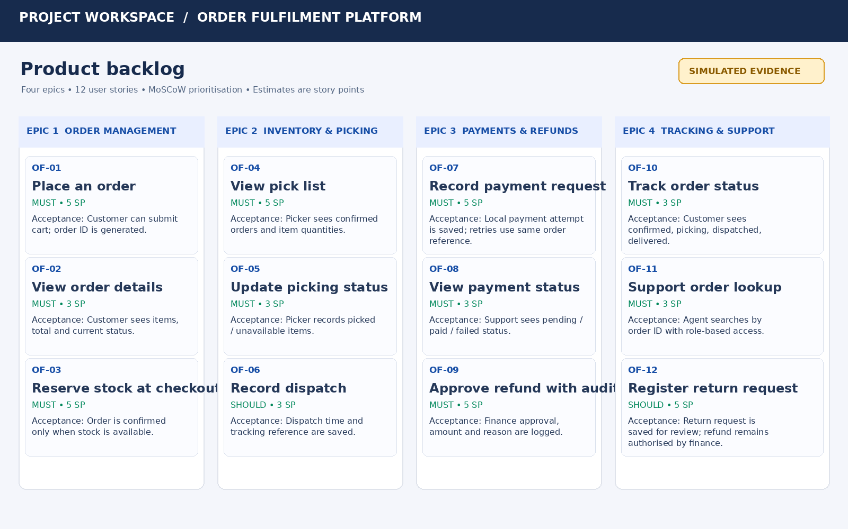

3.3 Competing stakeholder priorities
- Warehouse requested accurate reservation and pick lists, while management wanted a broad storefront feature set. Stock reservation and picking are prioritised because a polished storefront cannot prevent failed fulfilment if stock is wrong.
- Finance requested complete reconciliation while support requested fast order visibility. The first release includes payment status visibility and an auditable human refund approval, while advanced reconciliation automation is deferred until gateway access and finance rules are confirmed.

3.4 Definition of Ready (DoR)
- Story has a clear user and business outcome.
- Acceptance criteria are testable and include relevant failure cases.
- Dependencies and affected roles are identified.
- Estimate is agreed by the delivery team.
- Synthetic data and required environment are available or a documented stub exists.

3.5 Definition of Done (DoD)
- Code is reviewed and integrated into the shared branch.
- Acceptance criteria and relevant automated/manual tests pass.
- No unresolved critical defect remains for the story.
- Role permissions, privacy and accessibility checks are completed where relevant.
- Data changes are persisted and audit events are verified where required.
- Documentation and user-facing status labels are updated.
- Product Owner accepts the story.

4. Task 4 – Create a Capacity-Based Release Plan and Delivery Workflow

4.1 Capacity and estimation assumptions
The baseline team has seven members. For planning only, assume each member has 10 focused delivery days across a two-week sprint after meetings, support and other duties. At 70% focus availability, this is approximately 49 person-days of usable team capacity per sprint. Story points are relative estimates of complexity, risk and effort; they are not hours and are not converted into fixed person-days. Since velocity is unknown, Sprint 1 is used to establish a baseline and later sprint scope is adjusted using observed throughput.

4.2 Four-sprint release plan
Sprint / weeks | Sprint goal | Main planned scope | Dependency / review
Sprint 1 / Weeks 1–2 | Create a reliable order foundation. | OF-01, OF-02, OF-03, OF-04, OF-05 plus test setup. | Validate stock rules with warehouse representative; gateway and scanner not yet available.
Sprint 2 / Weeks 3–4 | Connect payment records and support visibility. | OF-07, OF-08, OF-11; adapter interface and safe retry tests. | Gateway sandbox starts in week 4; use stub until then.
Sprint 3 / Weeks 5–6 | Complete dispatch and controlled returns. | OF-06, OF-09, OF-12, OF-10. | Scanner test device arrives week 5; validate device-dependent steps before claiming scanner support.
Sprint 4 / Weeks 7–8 | Harden and prepare the release. | End-to-end regression, permissions, audit checks, accessibility and release readiness. | Final operational review; resolve release-blocking defects.

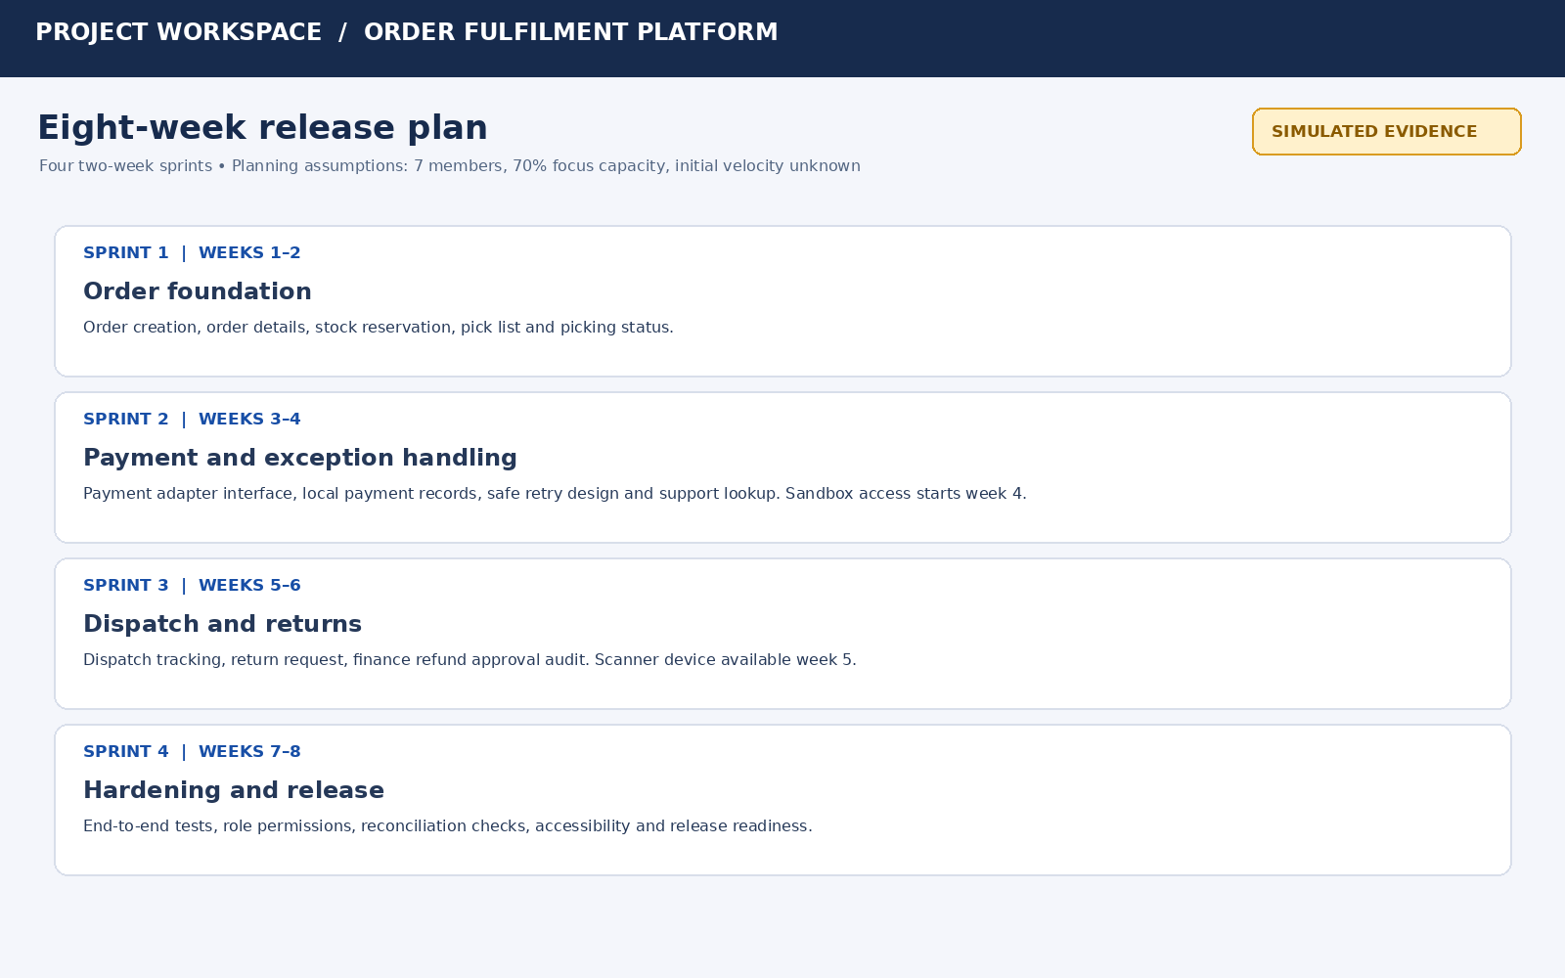

4.3 Development workflow and transition rules
Status | Entry / exit rule
Backlog | Idea or requirement captured; not yet refined.
Selected for Sprint | DoR satisfied; priority, estimate, owner and dependencies recorded.
In Progress | Developer starts work; WIP limit applies.
Blocked | A dependency or decision prevents progress; blocker, owner and next action recorded.
In Review / Testing | Implementation complete; peer review and acceptance tests underway.
Done | DoD satisfied and Product Owner acceptance recorded.

This development workflow is separate from the operational order lifecycle. The operational order lifecycle is: Created → Stock Reserved → Payment Pending/Paid/Failed → Picking → Dispatched → Delivered → Return Requested (if applicable) → Refund Pending Approval → Refunded/Rejected.
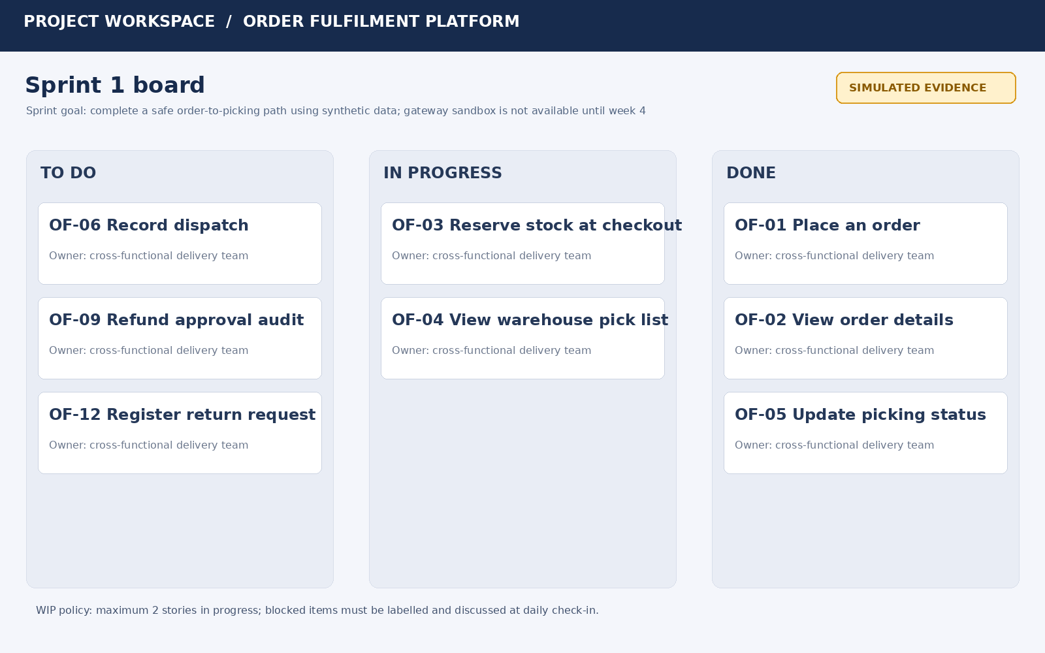

4.4 WIP and exception policies
- Baseline WIP limit: no more than two stories in In Progress at a time.
- Blocked story: move to Blocked, record cause and owner, and discuss at daily coordination.
- Urgent request: Product Owner assesses value and deadline impact; if accepted, another item is removed or deferred rather than silently increasing capacity.
- Unfinished story: return to backlog or carry forward only after re-estimation and dependency review; do not mark Done without DoD.

4.5 How the scope achieves the product goal
The selected features connect the customer order to stock reservation, warehouse picking and dispatch, while support can inspect order/payment status and finance retains control of refund approval. This creates a useful operational slice instead of delivering disconnected partial modules.

5. Task 5 – Simulate Delivery and Validate the Design

5.1 Predicted bottleneck
The most likely first-sprint bottleneck is clarification and dependency waiting around stock reservation and warehouse pick-list rules. The warehouse representative has limited availability, and stock reservation must be correct before picking can begin.
Control rule: refine stories before sprint planning, keep WIP at two, record blockers with owners, and reserve the weekly 90-minute stakeholder slot for decisions. Evidence of effectiveness includes reduced blocked time, fewer reopened stories and stable cycle time.

5.2 Sprint 1 simulated event log
Event | Simulated event | Board / process response
1 | Sprint planning selects eight stories within assumed capacity. | Stories selected for Sprint.
2 | OF-01 starts; Product Owner clarifies order ID behaviour. | Acceptance criteria updated.
3 | OF-02 starts after order data structure is agreed. | Work proceeds within WIP limit.
4 | OF-03 is blocked by a stock reservation dependency. | Move to Blocked; assign dependency owner.
5 | A duplicate-submit defect is found in order creation. | Record defect and pause completion.
6 | Team adds an idempotency check and retests OF-01. | Defect resolved; story returns to review.
7 | Warehouse representative clarifies unavailable-item handling. | OF-03 acceptance criteria refined.
8 | OF-04 pick-list story moves to In Progress. | Start only after reservation rules are clear.
9 | Review confirms five stories meet DoD. | Five stories marked Done.
10 | Three stories remain unfinished and are carried forward with reasons. | Backlog and next sprint plan updated.

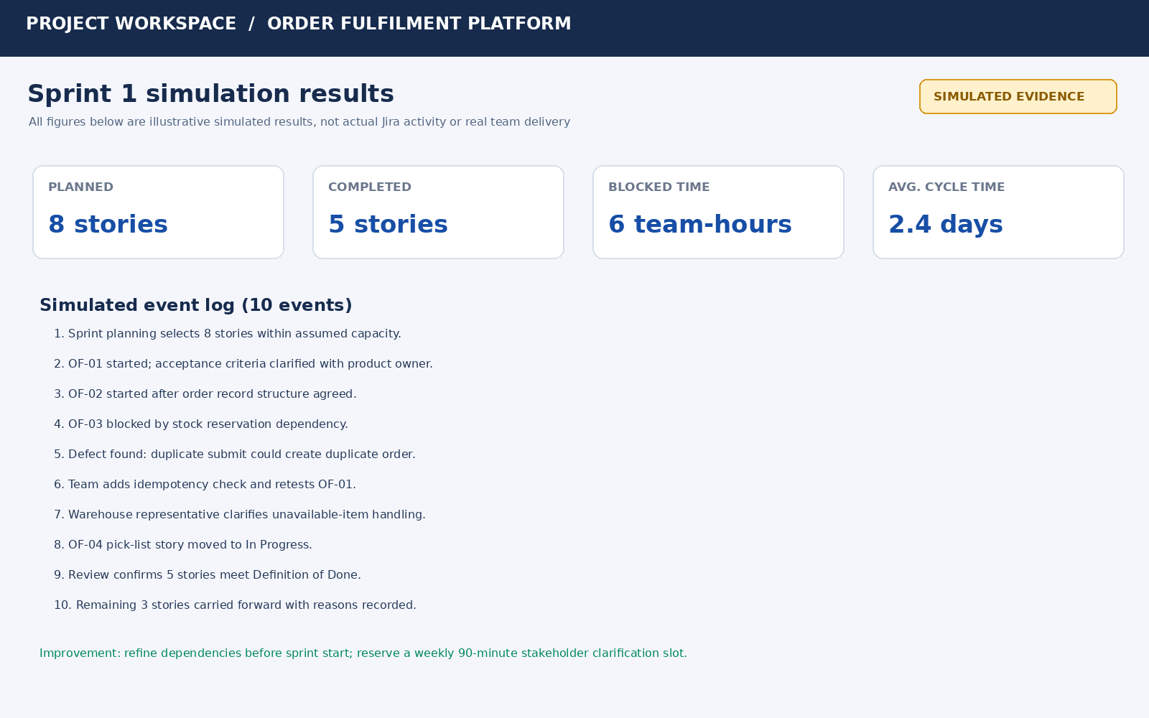

5.3 Simulated delivery indicators and interpretation
Indicator | Simulated result | Interpretation
Completed vs planned | 5 of 8 stories completed (62.5%). | The sprint goal was partly achieved; scope was too optimistic before dependencies were fully clarified.
Blocked time | 6 team-hours. | Clarification and stock dependency waiting affected flow.
Average cycle time | 2.4 days for completed stories. | Use as a baseline only; more sprint data is required for a reliable trend.
Reopened stories | 1 story required rework after defect discovery. | Earlier test cases for duplicate submission should be added to refinement.

5.4 Improvement for Sprint 2
The original plan is limited by insufficiently refined stock and integration dependencies. Before Sprint 2, the team will conduct a dependency review, prepare stubbed payment responses, add duplicate-request tests to the DoD and reserve the stakeholder slot for the highest-risk unresolved questions. Sprint 2 capacity will be based on the completed work and actual availability rather than assuming all planned stories will finish.

6. Task 6 – Redesign Delivery Under Changed Conditions

6.1 Impact diagnosis
Change | Impact on original plan | Response
Two additional regional warehouses | More warehouse configurations and region-specific fulfilment paths. | Add region configuration and warehouse validation stories.
Second seven-member team joins | Coordination and integration complexity increase; capacity does not simply double. | Split work by bounded domains and use shared standards.
Original payments engineer unavailable | Payment knowledge and gateway integration become a key-person dependency. | Document adapter contract, assign backup ownership and use sandbox-independent stubs.
Regional tax, shipping and refund rules | Pricing, shipping and refund logic vary by region. | Add configurable rule stories and region-specific tests.
Festival deadline unchanged | No extra time is available for the expanded scope. | Protect minimum viable journey; defer advanced analytics and non-essential automation.

6.2 Measurable redesign objectives
- Maintain the fixed eight-week festival-sale release date.
- Deliver the basic order-to-dispatch journey for the original and two additional warehouse regions using configured synthetic test data.
- Ensure every regional tax, shipping and refund rule has at least one positive and one negative test case.
- Keep one shared backlog and complete a cross-team integration review at least once per week.
- Keep critical payment behaviour safe through an adapter/stub and avoid claiming production gateway completion until access and a qualified owner are available.

6.3 Revised two-team strategy
Team | Primary ownership | Interfaces / coordination
Team A – Core order flow (7 members) | Order management, inventory reservation, picking, dispatch and shared order status. | Publishes stable order, stock and fulfilment API contracts; owns core end-to-end flow.
Team B – Regional operations (7 members) | Regional tax/shipping configuration, regional refund rules, warehouse setup and regional validation. | Consumes shared contracts; contributes integration tests and documents region-specific configuration.

Scaled Agile practices adopted: one shared product backlog, one product-level priority order, common Definition of Ready and Definition of Done, weekly cross-team planning, a dependency board, shared integration review and a single release goal. These are lightweight SAFe-inspired coordination practices rather than a claim that the organisation has implemented the full SAFe framework.
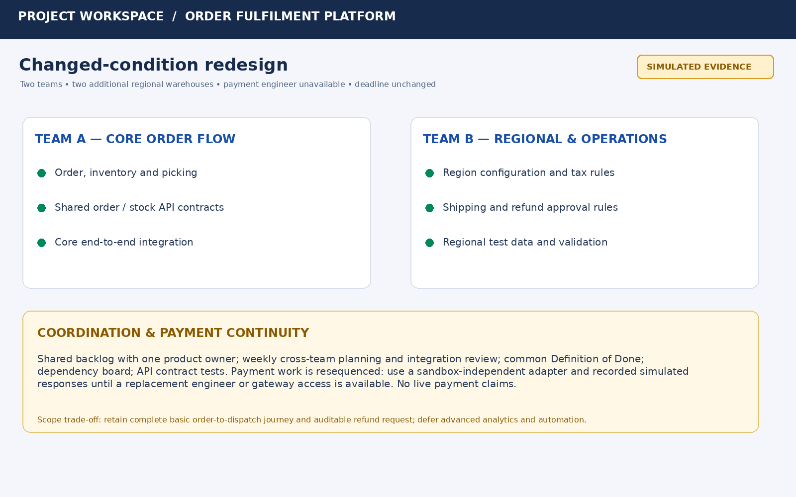

6.4 Revised sequencing and scope decisions
Release sequence | Retained / resequenced work | Deferred work
First priority | Core order, stock reservation, picking and dispatch; shared order status. | Advanced analytics and predictive forecasting.
Parallel regional work | Region configuration, tax and shipping rules, regional warehouse test cases. | Complex region-specific automation beyond validated rules.
Payment continuity | Payment adapter contract, local attempt records, retry safety and auditable refund approval rules. | Live gateway integration if no qualified replacement owner or sandbox access is available; automated refund approval.

6.5 Additional simulated events
Event | Simulated event | Revised response
1 | Regional warehouse asks for a different shipping rule. | Team B adds a configurable rule and test case.
2 | Payment engineer becomes unavailable. | Payment adapter documentation and backup ownership are prioritised.
3 | Team A and Team B discover a mismatch in order status naming. | Shared API contract is agreed and contract tests are added.
4 | Finance clarifies that refund approval differs by region. | Region-specific approval rule is added; human approval remains mandatory.
5 | Integration review identifies a regression in one warehouse flow. | Release candidate is held until the regional end-to-end test passes.

6.6 Comparative validation
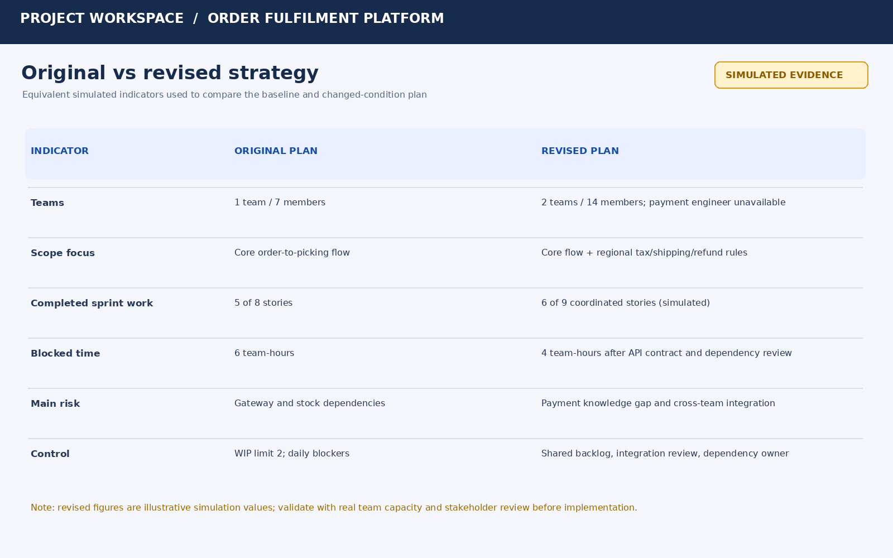
The revised simulation shows six of nine coordinated stories completed and four team-hours of blocked time, compared with five of eight and six team-hours in the original simulation. These are illustrative values, not measured performance. The revised approach improves visibility through explicit interface ownership and integration reviews, but cross-team coordination and payment knowledge remain risks.

6.7 Benefits, limitations and trade-offs
- Benefits: regional needs are represented, responsibilities are clearer, dependencies are visible and the fixed deadline is protected by prioritising the minimum useful release.
- Limitations: the payment engineer gap may prevent live gateway completion; two teams can create integration overhead; regional rules require careful stakeholder validation.
- Trade-off: advanced analytics and automated refund decisions are deferred so the order-to-delivery journey and auditable refund control remain achievable.

7. Task 7 – Individual Technical Reflection
The most significant decision was to prioritise stock reservation, picking and dispatch together with order visibility instead of attempting all nine proposed modules at once. This decision addresses the operational problem directly: a storefront alone cannot prevent failed fulfilment when stock and warehouse processes are disconnected.
The simulated Sprint 1 evidence showed that dependency clarification and a duplicate-submit defect reduced completion to five of eight planned stories. This led to an improvement in the plan: stronger refinement, explicit dependency ownership, a WIP limit of two and additional idempotency tests.
The final design remains vulnerable to delayed payment-gateway access, the loss of the payments engineer and regional rule changes. Before using the strategy with a real team, I would validate stakeholder assumptions, confirm actual team availability, test the payment provider contract, review security and privacy requirements, and measure cycle time over more than one sprint.
An ethical concern is the handling of customer and payment information. The design uses synthetic data, role-based access and auditable refund approvals. It avoids real card data and keeps refund approval under human responsibility. Accessibility checks are included in the Definition of Done.
The simulation helped identify that a plan should be revised using evidence rather than treating estimates as guarantees. The revised plan retains the essential order journey and adds regional configuration while deferring lower-priority features.

Conclusion
The proposed Agile delivery strategy combines Scrum, Lean flow controls and selected XP practices to deliver a feasible eight-week first release. Jira is suitable for managing epics, user stories, sprint work, dependencies and delivery indicators. The simulated first sprint exposed the need for stronger dependency refinement and stakeholder clarification. Under changed conditions, a two-team model with shared standards and explicit integration coordination preserves the core release while addressing regional requirements. The strategy remains conditional on validating assumptions with real stakeholders and confirming payment integration ownership.

References and Tools
- CSA10 Software Engineering Assignment 1 brief supplied for this task: “Design, Simulate and Validate an Agile Delivery Strategy for the Omnichannel Order Fulfilment Platform.”
- Atlassian Jira – proposed project-management tool; feature and plan availability should be checked against the account used.
- Trello – alternative visual Kanban tool considered in the tool comparison.
- All stakeholder responses, delivery metrics, event logs and board screenshots in this report are simulated academic examples prepared for this assignment.

